**Entrega 1 Análisis de dades**

**14-10-2019**

**Provide the MySQL query statement and the resulting graph for each of the following KPIs.**

**Copy both the query code and the graph below each question**

**MONETIZATION**

Make a list of all paying users (full name and amount spent) ordered in descending order by amount spent

*-- create or replace view PayingUsers as*

*select*

*concat(u.firstName, " ", u.lastName) as "Full Name",*

*ifnull(sum(t.totalPrice), 0) as "€Spent"*

*from users as u*

*left join sessions as s on u.user_id = s.player_id*

*left join transactions as t on s.session_id = t.session_id*

*group by u.user_id*

*order by 2 desc*

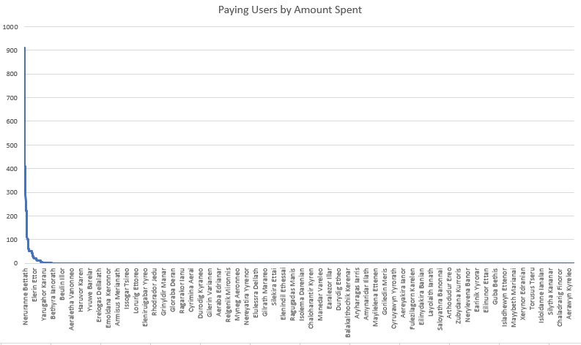

Get ARPDAU (by date)

*-- create or replace view ARPDAU as*

*select*

*date(d.date) as "Date",*

*ifnull(sum(t.totalPrice)/count(distinct s.player_id), 0) as "ARPDAU"*

*from dates as d*

*left join sessions as s on date(s.start) = date(d.date)*

*left join transactions as t on s.session_id = t.session_id*

*group by 1*

*order by 2 desc*

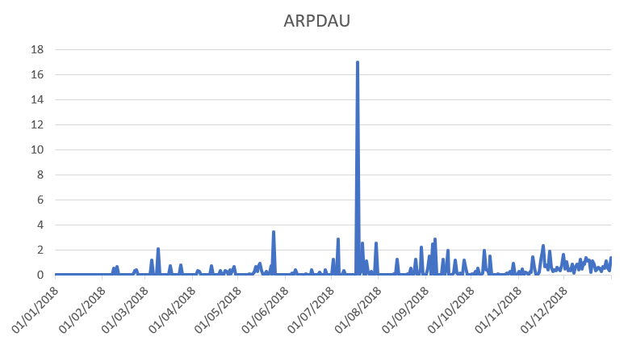

Get ARPDAU (by date) by gender

-- create or replace view ARPDAU_Gender as

select

date(d.date) as "Date",

ifnull(sum(case when u.sex = "M" then (t.totalPrice) end) / count(distinct case when u.sex = "M" then s.player_id end), 0) as "ARPDAU_Men",

ifnull(sum(case when u.sex = "F" then (t.totalPrice) end) / count(distinct case when u.sex = "F" then s.player_id end), 0) as "ARPDAU_Women"

from dates as d

left join sessions as s on date(s.start) = date(d.date)

left join transactions as t on s.session_id = t.session_id

left join users as u on u.user_id = s.player_id

group by 1

order by 1 desc

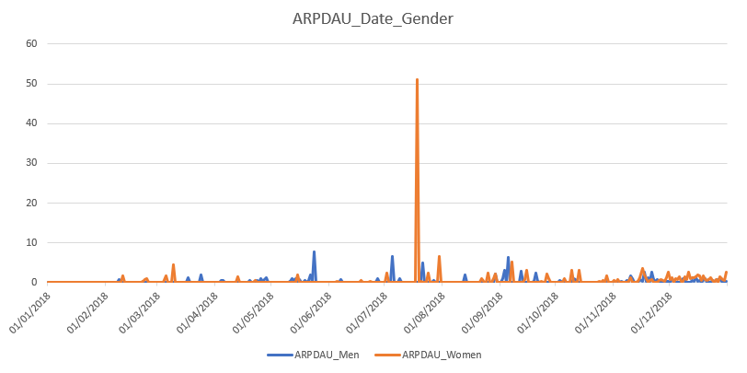

Get ARPPU by country

-- create or replace view ARPPU_Country as

select

u.country as Country,

sum(t.totalPrice) / count(u.user_id) as ARPPU

from transactions as t

left join sessions as s on s.session_id = t.session_id

left join users as u on u.user_id = s.player_id

group by u.country

order by 2 desc

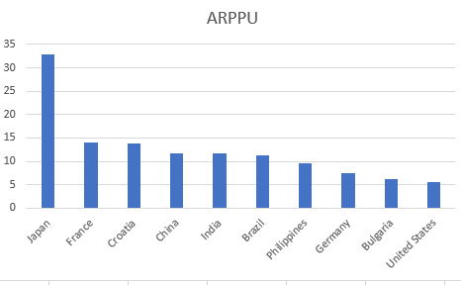

Get ARPU by country

-- create or replace view ARPU_Country as

select

u.country as Country,

sum(t.totalPrice) / count(u.user_id) as ARPU

from users as u

left join sessions as s on s.player_id = u.user_id

left join transactions as t on t.session_id = s.session_id

group by 1

order by 2 desc

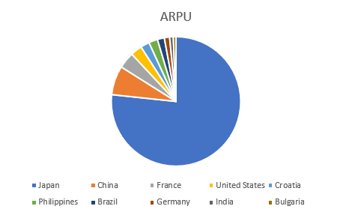

Get conversion rate (transactions / user) by date

select

date(d.date) as "Date",

ifnull(count(t.transaction_id) / count(u.user_id), 0) as "Conversion Rate"

from dates as d

left join sessions as s on date(s.start) = date(d.date)

left join users as u on u.user_id = s.player_id

left join transactions as t on t.session_id = s.session_id

group by 1

order by 1

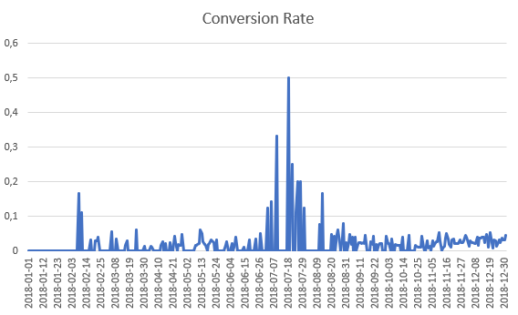

Revenue per transaction by date

select

date(d.date) as "Date",

ifnull(sum(t.totalPrice) / count(t.transaction_id), 0) as "RevenuePerTransaction"

from dates as d

left join transactions as t on date(t.date) = date(d.date)

group by 1

order by 1

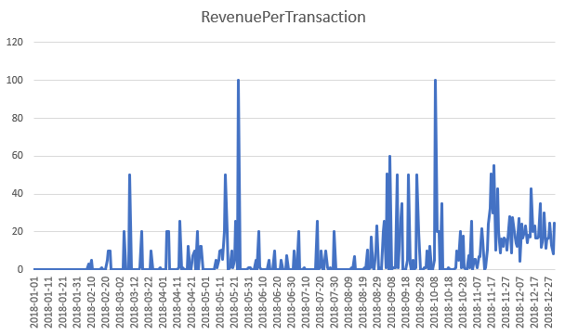

Number of transactions by date

select

date(d.date) as "Date",

count(t.transaction_id) as "Number of Transactions"

from dates as d

left join transactions as t on date(t.date) = date(d.date)

group by 1

order by 1

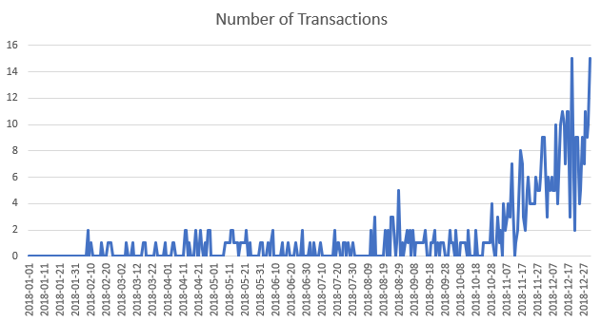

Revenue per item by date

select

date(d.date) as "Date",

ifnull(sum(t.totalPrice) / sum(t.amount), 0) as "Revenue Per Item"

from dates as d

left join transactions as t on date(t.date) = date(d.date)

group by 1

order by 1

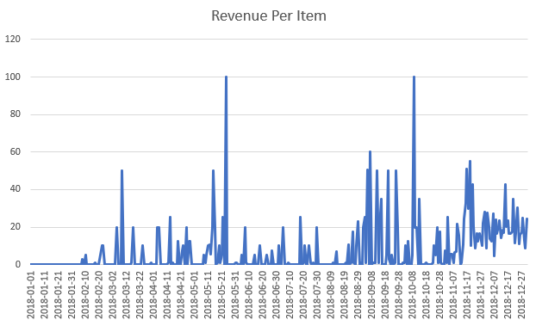

**USERS**

Session count (number of sessions) per day

select

date(d.date) as "Date",

count(session_id) as "SessionCount"

from dates as d

left join sessions as s on date(s.start) = date(d.date)

group by 1

order by 1

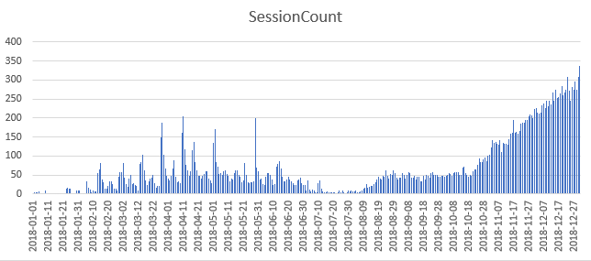

Get new users per day

select

date(d.date) as "Date",

count(u.user_id) as "New Users"

from dates as d

left join users as u on date(u.dateCreated) = date(d.date)

group by 1

order by 2 desc

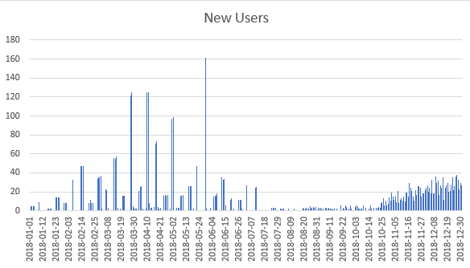

Get DAU per day (daily active users per day)

-- create or replace view DAU as

select

date(d.date) as "Date",

count(distinct s.player_id) as "Distinct Active Users"

from dates as d

left join sessions as s on date(s.start) = date(d.date)

group by 1

order by 1

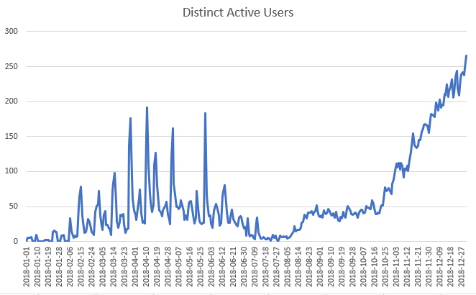

Get DAU per day by gender

select

date(d.date) as "Date",

count(distinct case when u.sex = "M" then s.player_id end) as "DAU_Men",

count(distinct case when u.sex = "F" then s.player_id end) as "DAU_Women"

from dates as d

left join sessions as s on date(s.start) = date(d.date)

left join users as u on u.user_id = s.player_id

group by 1

order by 1

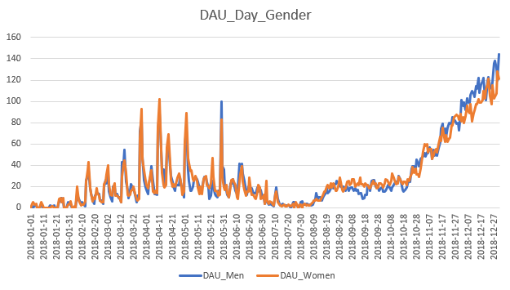

Get sessions/user per day

select

date(d.date) as "Date",

ifnull(count(s.session_id) / count(distinct s.player_id), 0) as "Sessions by User"

from dates as d

left join sessions as s on date(s.start) = date(d.date)

left join users as u on u.user_id = s.player_id

group by 1

order by 1

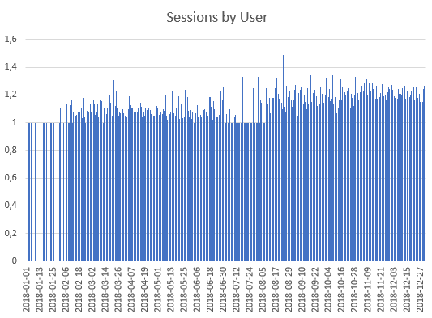

Get avg session length per day

select

date(d.date) as "Date",

ifnull(minute(avg(s.lastControl - s.start)), 0) as "AV Session Length"

from dates as d

left join sessions as s on date(s.start) = date(d.date)

group by 1

order by 1

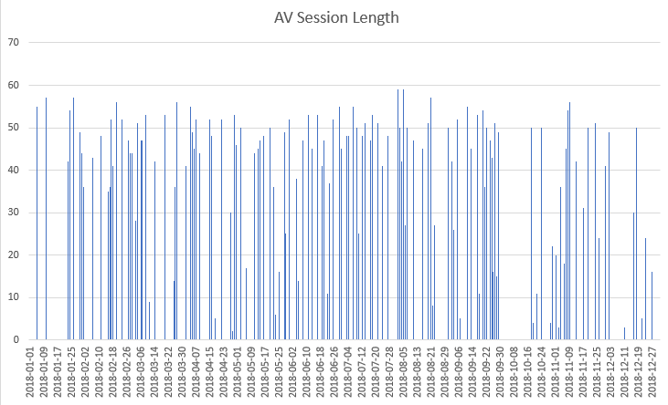

**RETENTION**

Get D1 per day

Get D3 per day

Get D7 per day

Get stickiness (DAU/MAU) per day

-- CALCULATE STICKINESS

select

date(d.date) as "Date",

ifnull(MAU.DAU / MAU.MAU, 0) as "Stickiness"

from dates as d

left join

(

-- CALCULATE MAU

select

DAU.Date as "Date",

DAU.DAU as "DAU",

count(distinct s.player_id) as "MAU"

from

(

-- CALCULATE DAU

select

date(d.date) as "Date",

count(distinct s.player_id) as "DAU"

from dates as d

left join sessions as s on date(s.start) = date(d.date)

group by 1

order by 2 desc

) as DAU

left join sessions as s on date(s.start) < date(DAU.Date) and date(s.start) > date(DAU.Date) - interval 1 month

group by 1

order by 1

) as MAU on date(MAU.Date) = date(d.date)

